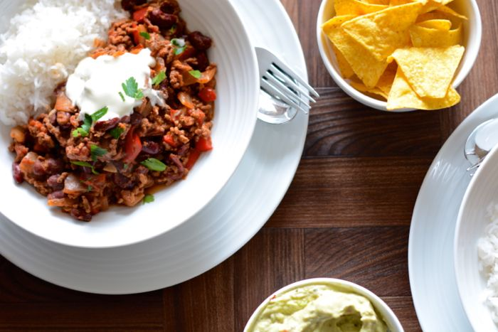Chilli Con Carne:

# Ingredients:

* 500g of Minced Meat
* 1 Onion
* 1 Tbsp garlic powder
* 1-2 Tsp chilli powder
* 1 Level tbsp flour
* 1 Tbsp tomato puree
* 1 Beef stock cube
* Salt and pepper to season
* 2 Large cans of chopped tomatoes
* 1 Can of kidney beans
* 1 Can of baked beans

# Method:

With this recipe you have two options. You can make the chilli con carne to eat on the day or premake for a few days time or, as I like to do, portion off the chilli and freeze for a low effot mid- week meal. All you would have to do is defrost a portion and cook some rice or chips to go with it, whichever takes your fancy! Maybe even add some tortilla chips on the side for dipping. Personally, I find that there is more than enough for one portion if you follow the quantities in this recpie so you could even eat some fresh *and* save the rest for another day in the fridge or portion it to freeze.

1. If you don't intend on freezing the chilli in portions, you will need to make your rice/ chips etc according to the packet as you complete the rest of these instructions. Otherwise, skip to the next step.
2. Cook the minced meat in a large frying pan on medium gas with a little oil for approximately 15 minutes until almost cooked through.
3. Finely dice the onion before adding to the pan, cook for another 5 mins until the onion has softened slightly and then drain off as much fat as you can.
4. Add the garlic powder, flour, chilli powder, tomato puree, crumbled stock cube and seasoning then mix thoroughly.
5. Add the contents of both tins of tomatoes to the pan and stir.
6. Bring the mixture to the boil then simmer for 20 minutes.
7. Drain and rinse the kidney beans in the sink before adding them to the pan.
8. Add the tin of baked beans to the pan and stir well.
9. Cook on a low heat for another 5 minutes before serving.

If you are going to freeze your chilli or put some in the fridge for another day, make sure that you leave it to cool sufficiently before doing so.